

AN ISO 9001:2015, 14001:2015, 21001:2018, 45001:2018 CERTIFIED TRAINING INSTITUTION

**NETTUR TECHNICAL EDUCATION CENTER**

**SYNOPSIS**

ON

# VEHICLE SERVICING SYSTEM

PROJECT DONE BY

**CHANDAN SINGH (RNTC0822008)**

MUNIKOTI BHARGAV KR. (RNTC0822026)

SURYA PRAKASH TIWARY (RNTC0822012)

SONAL SINGH (RNTC0822037)

**DIPLOMA IN COMPUTER ENGINEERING AND IT INFRASTRUCTURE**

NTTF AT R D TATA TECHNICAL EDUCATION CENTRE

GOLMURI, AGRICO POST, JAMSHEDPUR

2022 – 2025



AN ISO 9001:2015, 14001:2015, 21001:2018, 45001:2018 CERTIFIED TRAINING INSTITUTION

**NETTUR TECHNICAL TRAINING FOUNDATION**

***CERTIFICATE***

This is to certify that the project titled

# VEHICLE SERVICING SYSTEM

Is a bona fide record of the project work done by

**CHANDAN SINGH (RNTC0822008)**

MUNIKOTI BHARGAV KR. (RNTC0822026)

SURYA PRAKASH TIWARY (RNTC0822012)

SONAL SINGH (RNTC0822037)

In partial fulfilment of the requirement for the award of Diploma in Computer Engineering and IT Infrastructure under the institution Nettur Technical Training Foundation, Jamshedpur Training Centre, during the Academic year 2022 – 2025.

**PROJECT GUIDE EXTERNAL EXAMINER PRINCIPAL**

**ACKNOWLEDGEMENT**

We hereby declare that we the members of the team “TECH OF TURTULE”, would like to accomplish our Web based project under the guidance of Mr. Mrinmoy Kumar Mahato. We are very thankful to Bibek Sir, Smruti Mam & Shilpa Mam all the Supporting Staff Members who helped and motivated us whenever required. We are very grateful to our Principal Madam, Mrs. Preeta John for giving us this golden chance to explore ourselves. Last but not the least, we would like to thank our Classmates who were ready to help us whenever required.

**THANK YOU.**

## **CONTENTS**

|  |  |  |
| --- | --- | --- |
| **S.NO** | **TOPIC** | **PAGE NO.** |
| 1 | INTRODUCTION | 1 |
| 2 | FEASIBILITY STUDY | 2 |
| 3 | OBJECTIVE | 3 |
| 4 | TARGET AUDIENCE | 4 |
| 5 | ADVANTAGES | 5 |
| 6 | DIS-ADVANTAGES | 6 |
| 7 | MODULES AND FUNCTIONALITIES | 7 |
| 8 | FLOWCHART | 8 |
| 9 | ER DIAGRAM | 9 |
| 9 | DFD | 10-11 |
| 10 | REQUIREMENTS | 12-14 |
| 11 | SCHEDULE FOR PROJECT / GANTT CHAT | 15 |
| 12 | BIBLIOGRAPHY | 16 |
| 13 | CONCLUSION | 17 |
|  | | |

**INTRODUCTION**

A **Vehicle Service System** is a comprehensive framework or software solution designed to manage and streamline the maintenance, repair, and management of vehicles. It serves as a tool for vehicle owners, fleet managers, or auto service centers to ensure vehicles are properly serviced, maintained, and repaired in a timely and efficient manner. The primary purpose of a vehicle service system is to track the performance and condition of vehicles, schedule maintenance, manage repairs, and ensure the overall safety, reliability, and longevity of the vehicles.

**Page | 1**

**Feasibility Study**

* Market Feasibility
* Technical Feasibility
* Operational Feasibility
* Financial Feasibility
* Schedule Feasibility

**Page |2**

**OBJECTIVE**

The primary objective of a ***Vehicle Servicing System*** is to streamline the process of scheduling, managing, and tracking appointments efficiently and effectively through an online platform. This system aims to benefit both service providers and clients by offering automation, convenience, and flexibility in appointment management.

Here are some key objectives:

* Simplifying Appointment Scheduling
* Enhancing Customer Convenience
* Improving Time Management and Resource Utilization
* Providing Real-Time Availability and Flexibility

**Page | 3**

**TARGET AUDIENCE**

* **Vehicle Owners:** Individual seeking reliable and convenient vehicle servicing and maintenance.
* **Independence Service Centers:** Small to medium-sized garages offering general vehicle repair and maintenance.
* **Authorized Dealerships and Workshops:** Service centers of automotive brands offering specialized services and repairs.
* **Technicians:** Personnel responsible responsible for carrying out maintenance and repair, who will use the system to receive service assignments and track job status.

**Page | 4**

**ADVANTAGES**

A vehicle service system, which typically involves the maintenance, repair, and management of vehicle, offers several advantages.

* Improved Vehicle Performance
* Increased Vehicle Lifespan
* Reduce Risk of Breakdown
* Enhanced Safety
* Cost Saving
* Better Fuel Efficiency
* Higher Resale Value
* Better Driving Experience

**Page | 5**

**DIS-ADVANTAGES**

While vehicle service system offers many advantages, there are also some potential disadvantages to consider.

* Dependence on Service Providers
* Cost of Service
* Over-Scheduling and Delay
* Risk of Over-Maintenance
* Limited Service Quality
* Part Availability
* Lack of Transparency
* Time-Consuming

**Page | 6**

**FUNCTIONALITIES**

* Vehicle Maintenance Scheduling
* Parts Management and Inventory
* Customer Management and Communication
* Vehicle Inspection and Monitoring
* Cost Estimation and Billing
* Repair Management
* Reporting and Analytics
* Mobile and Remote Access
* Maintenance History and Warranty Tracking

**Page | 7**

**FLOWCHART**

**START**

**INPUT BY USER**

**YES**

**NO**

**IF USER ALEADY**

**REGISTER**

**LOGIN**

**REGISTER**

USER DASHBOARD

SERVICE 2

SERVICE 3

SERVICE 1

MAIL REGARDING SERVICE SEND TO THE USER

PAYMENT BY USER

ALL DATA SEND TO THE ADMIN

ADMIN DASHBOARD

**Page | 8**

**ER DIAGRAM**

**LOGIN**

**(INDEX)**

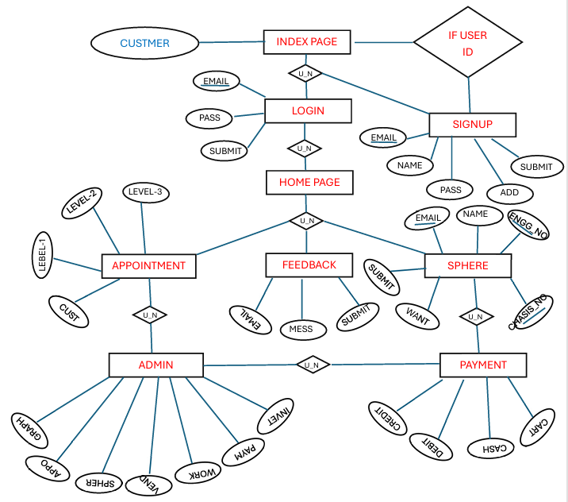

**REGISTER**

**HOME PAGE**

**B2**

**B3**

**B1**

**ADMIN PAGE**

**Page | 9**

**DFD**

**DFD-0**

**DFD-1**

**Page | 10**

**DFD-2**

**Page | 11**

**REQUIREMENTS**

**Software Requirements:-**

**SPECIFICATION**

|  |  |
| --- | --- |
| **Operating System** | Windows |
| **SOftware** | Visual Studio Code |
| **Language** | HTML,CSS,JAVASCRIPT,PHP |
| **DataBase** | MYSQLI |
| **Server** | XAMPP SERVER |
| **Browser** | Any browser |
| **Testing Tool** | Selenium |

**Hardware Requirements:-**

**Specification:**

|  |  |
| --- | --- |
| **Accessories** | Laptop |
| **Hard Disk** | 50GB or More Storage Space |
| **RAM** | 4Gb Ram or More |
| **Processor** | Intel core i5 10500U @ 2.5GHz |
| **Printer** | A network printing report and bills |

**Page | 12**



**HTML (Hyper Text Markup Language) – A Comprehensive Definition**

HTML (HyperText Markup Language) is the foundational language used to create and structure web pages on the internet. It provides a standardized way to organize content, ensuring that web browsers like Google Chrome, Mozilla Firefox, and Microsoft Edge can interpret and display it correctly. HTML is not a programming language but a markup language that structures web content through a system of elements and tags.

**CSS (Cascading Style Sheets) – A Comprehensive Definition**

CSS (Cascading Style Sheets) is a stylesheet language used to describe the presentation and layout of web pages. It controls how HTML elements appear on the screen, including aspects like colors, fonts, spacing, positioning, and animations. By separating content (HTML) from design (CSS), it enhances web development efficiency, making websites visually appealing and user-friendly.





**JavaScript (JS) – A Comprehensive Definition**

JavaScript (JS) is a high-level, interpreted programming language that enables dynamic and interactive web content. It is one of the core technologies of web development, alongside **HTML (HyperText Markup Language)** and **CSS (Cascading Style Sheets)**. While HTML structures a webpage and CSS styles it, JavaScript adds interactivity, making it more engaging for users.

Initially designed for web browsers, JavaScript has evolved into a versatile language that powers web applications, mobile apps, server-side applications (via **Node.js**), and even game development.

**Page | 13**



**PHP (Hypertext Preprocessor) – A Comprehensive Definition**

PHP (Hypertext Preprocessor) is a widely used, open-source server-side scripting language designed primarily for web development. It enables dynamic content creation, database interactions, and server-side functionalities, making it a key component in web applications. PHP scripts are executed on the server, and the resulting HTML is sent to the client’s browser.

PHP was originally created by Rasmus Lerdorf in 1994 and has since evolved into a powerful language with extensive support for databases, security, and scalability. It is commonly used in combination with **HTML, CSS, JavaScript, and MySQL** to develop full-fledged web applications.

**MySQLi (MySQL Improved) – A Comprehensive Definition**

**MySQLi (MySQL Improved)** is an extension of PHP that provides an enhanced interface for interacting with MySQL databases. It was introduced in **PHP 5.0** as an improvement over the older **MySQL extension**, offering better performance, security, and support for **prepared statements**, **transactions**, and **object-oriented programming (OOP)**.

Developers use MySQLi to **connect, query, and manipulate** databases efficiently. It is one of the two main options for database interaction in PHP, with the other being **PDO (PHP Data Objects)**. MySQLi is **MySQL-specific**, whereas PDO supports multiple database types.

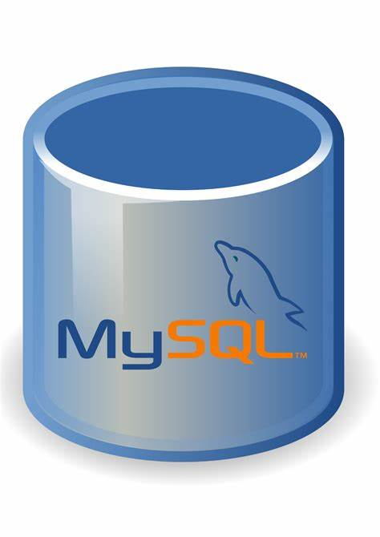



Visual Studio Code (VS Code) is a **free**, **open-source**, and **lightweight** code editor developed by **Microsoft**. It works on **Windows, macOS, and Linux**, and it's popular among developers for writing and editing code in a variety of programming languages



**Git** is a **distributed version control system** used to track changes in source code during software development. It helps multiple developers collaborate on a project by keeping a history of every change, allowing them to work on the same codebase without interfering with each other.



**Page | 14**

**SCHEDULE FOR PROJECT**

**DATA FROM GANTT CHART:-**

**DATA FROM GANTT CHART:-**

1. **WEEK 1-3**🡪**PREPARATION**
2. **WEEK 4🡪FLOW CHART**
3. **WEEK 5-24🡪PROGRAMMING**
4. **WEEK 25-27🡪FINAL MAKEOVER**
5. **WEEK 5-39🡪PROJECT TESTING**

**START DATE🡪 2nd January**

**FINISH DATE🡪 31th June**

**Page | 15**

**BIBLIOGRAPHY**

For the successful completion of the project we have taken references from:-

1. W3school.com
2. Fontawsome.com
3. Wikipedia.com
4. Geeksforgeeks.com
5. Github.com

**Page | 16**

**CONCLUSION**

The ***Vehicle Servicing System*** is to improve the appointment scheduling process for both service providers and clients by offering automation, flexibility, and efficiency. By achieving these objectives, the system enhances the overall customer experience, improves operational efficiency, reduces administrative overhead, and fosters business growth. Ultimately, it provides a more seamless and professional way to manage appointments in various industries, ranging from healthcare to beauty services and beyond.

**Page | 17**